**Circuit and System-I**

**LAB # 04**



**Spring 2022**

Submitted by: Ali Asghar

Registration No.: **21PWCSE2059**

Class Section: **C**

“On my honor, as student of University of Engineering and Technology, I have neither given nor received unauthorized assistance on this academic work.”

Student Signature: ______________

Submitted to:

**Engr. Faiz Ullah**

19 May, 2022

Department of Computer Systems Engineering

**ASSESSMENT RUBRICS LAB # 04**

**Verification of Ohm’s law Using Bread-Board**

|  |  |  |  |  |
| --- | --- | --- | --- | --- |
| **LAB REPORT ASSESSMENT** | | | | |
| **Criteria** | **Excellent** | **Average** | **Nil** | **Marks Obtained** |
| 1. **Objectives of Lab** | All objectives of lab are properly covered  [Marks 1] | Objectives of lab are partially covered  [Marks 0.5] | Objectives of lab are not shown  [Marks 0] |  |
| 1. **Ohm’s Law and Mathematical Expression.** | Correct definition of Ohm’s law, mathematical expression and circuit diagram is shown.  [Marks 1] | Correct statement of Ohm’s law and no mathematical expression and circuit diagram with no labels.  [Marks 0.5] | No definition, mathematical expression and circuit diagram is shown [Marks 0] |  |
| 1. **Apparatus Used** | All equipment and electrical components used are shown  [Marks 1] | Equipment and electrical components are partially shown and some of the components are missing [Marks 0.5] | Equipment and electrical components used are not shown  [Marks 0] |  |
| 1. **Procedure** | All experimental steps are shown in detail  [Marks 2] | Some of the experimental steps are missing [Marks 1] | Experimental steps are missing  [Marks 0] |  |
| 1. **Observations & Calculations** | All experimental results are completely shown in form of table and error calculation between theoretical and practical values are also shown.  [Marks 2] | Experimental results are partially shown and some of the observations are missing.  [Marks 1] | No experimental results are shown  [Marks 0] |  |
| 1. **Graphs** | Graphs from experimental results of Ohm’s law using theoretical and practical are shown with labels. [Marks 2] | Graphs from experimental results of Ohm’s law are shown with no labels and no comparison of theoretical and practical values. [Marks 1] | No graphs are shown  [Marks 0] |  |
| 1. **Conclusion** | Conclusion about experimental results is properly explained and satisfactory. [Marks 1] | Conclusion about experimental results is not properly explained and satisfactory. [Marks 0.5] | No conclusion is shown  [Marks 0] |  |
| Total Marks Obtained:__________  Instructor Signature: ______________________ | | | | |
|  | | | | |

**Title:**

Verification of **OHM’S LAW** using **BREADBOARD**

**Objectives** :

* To verify ohm’s law through practical experiment.

**Apparatus:**

1. Power supply
2. Breadboard
3. Wires
4. Digital Multimeter
5. Resistor

**Ohms law:**

**Definition**:

Ohm’s law states that the current in an electric circuit is proportional to the applied voltage and inversely proportional to its resistance*.*

**Mathematical Expression:**

V = IR

**Circuit Diagram :**

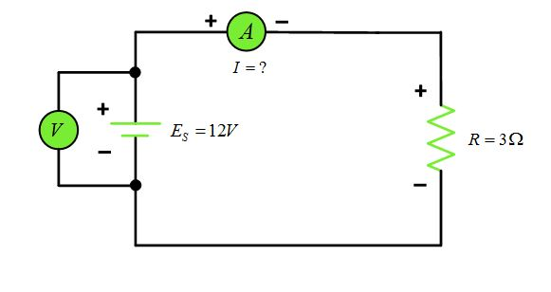

**PROCEDURE:**

1. First we connect the components and the wires according to the circuit diagram as given below:
2. We set the power supply at certain voltage and then measure the current through digital multimeter.
3. Repeat the previous step several times and then graph all the values.
4. If the graph is straight line then this verifies the ohm’s.

**OBSERVATION:**

|  |  |  |
| --- | --- | --- |
| S.No. | Voltage(V) | Current(I) |
| 1 | 5 | 312.5 µA |
| 2 | 10 | 625.00 µA |
| 3 | 15 | 937.50 µA |
| 4 | 20 | 1.250 mA |
| 5 | 25 | 1.563 mA |
| 6 | 30 | 1.875 mA |

**GRAPH:**

**THEORITICAL GRAPH:**

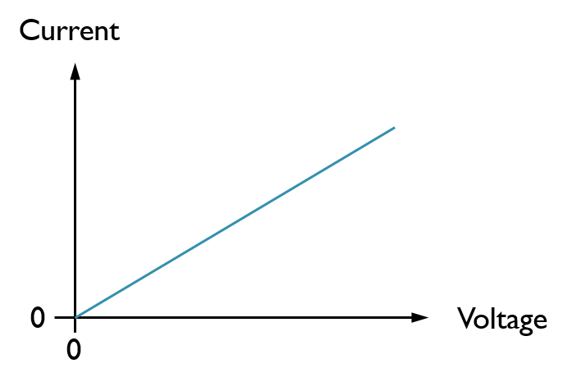

**PRACTICAL GRAPH:**

